**U.S. Hash Brown Potatoes Layered With Avocado and Shrimp**

**Makes 5 portions**

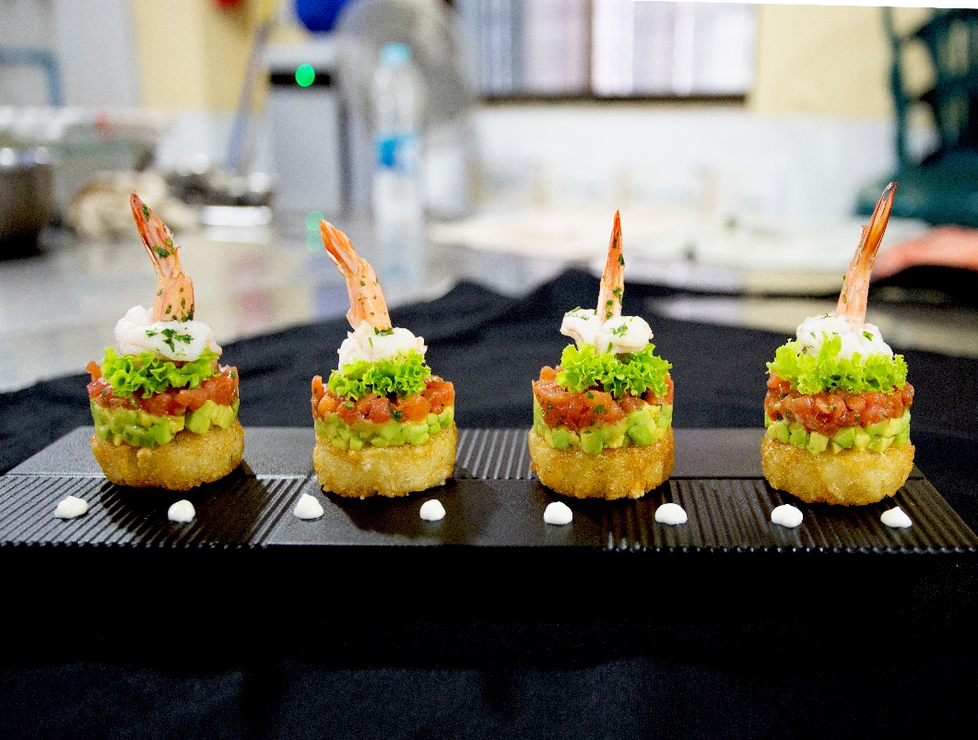

**Ingredients:**

15 grams : Shrimp (medium sized)

15 pieces : Hash Brown Potatoes

2 pieces : Avocado (to be diced up later)

100 grams : Green lettuce

5 pieces : Tomatoes (to be diced up later)

20 grams : Parsley (chopped)

50 ml : Lime juice

20 ml : Olive Oil

50 ml : Mayonnaise

To taste : Salt

To taste : Pepper

**Instructions for the shrimp**

1. Firstly make it swan shape of the shrimp

2. After blanching the shrimp, marinate them with some lime juice, chopped parsley, salt, pepper and olive oil

3. Slice the tomato skins and blanch them in hot water for 30 seconds. After removing the skin and seeds, mince the tomatoes and add seasoning

4. Dice the avocadoes and marinate with some lime juice, salt, pepper and olive oil

5. Deep fry the U.S. Hash Brown Potatoes and keep them cool for around 2 to 3 minutes

**Instructions for serving**

1. When the Hash Browns become warm, layer them with the diced up avocadoes and tomatoes
2. Top with some lettuce and shrimp then put on the plate and garnish with some mayonnaise